Assignment 4: Create Stored procedure in Northwind database to insert or update a record in a table

Query: Create a stored procedure in the Northwind database that will calculate the average value of Freight for a specified customer.Then, a business rule will be added that willbe triggered before every Update and Insert command in the Orders controller,and will use the stored procedure to verify that the Freight does not exceed the averagefreight. If it does, a message will be displayed and the command will be cancelled.

Sol: CREATE PROC insert_orders

@customerid NCHAR(5), @Freight MONEY

AS

BEGIN

DECLARE @avgfreight MONEY

SELECT @avgfreight = AVG(Freight) FROM Orders GROUP BY CustomerID HAVING CustomerID = @customerid;

IF @Freight > @avgfreight

BEGIN

PRINT 'Freight value is greater than average value';

RETURN

END

END

EXEC insert_orders 'ALFKI',50

Query:2 write a SQL query to Create Stored procedure in the Northwind database to retrieve Employee Sales by Country

Sol: create proc spemployeesalesbycountry

as

begin

select e.FirstName,e.LastName,e.Country,sum(Subtotal) as sales from [Orders] o join [Order Subtotals] od on o.OrderID=od.OrderID join

Employees e on o.EmployeeID=e.EmployeeID

group by e.Country,e.FirstName,e.LastName

end

exec spemployeesalesbycountry

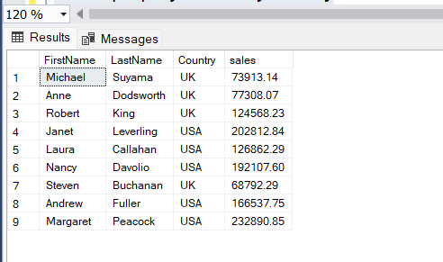

Query:3 write a SQL query to Create Stored procedure in the Northwind database to retrieve Sales by Year.

Sol: create proc spsales_by_year

as

begin

select sum(od.Subtotal) as sales ,YEAR(orderdate) as year from orders o join [Order Subtotals] od on o.OrderID=od.OrderID

group by YEAR(orderdate)

end

exec spsales_by_year

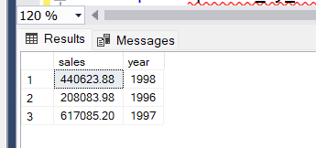

Query:4) write a SQL query to Create Stored procedure in the Northwind database to retrieve Sales By Category

Sol: create proc spsales_by_category

as

begin

select categoryname,sum(productsales) from [Sales by Category] group by CategoryName

end

exec spsales_by_category

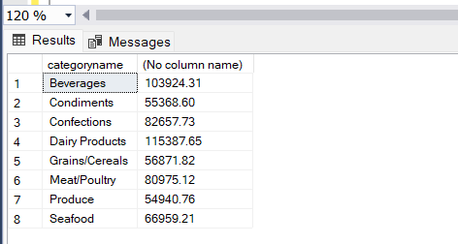

Query:5)write a SQL query to Create Stored procedure in the Northwind database to retrieve Ten Most Expensive Products

Sol: create proc sptop_10_most_expensive_prd

as

begin

select top 10 ProductName,UnitPrice from Products order by UnitPrice desc

end

exec sptop_10_most_expensive_prd

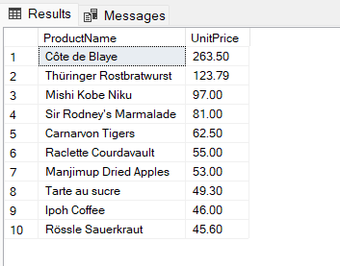

Query:6) write a SQL query to Create Stored procedure in the Northwind database to insert Customer Order Details.

Sol: create proc spcustomer_order_details

@orderid int,@productid int,@unitprice money,@quantity smallint,@discount real

as

begin

insert into [Order Details] values (@orderid ,@productid ,@unitprice,@quantity ,@discount)

end

spcustomer_order_details 10456,66,45.87,13,0

Query:7) write a SQL query to Create Stored procedure in the Northwind database to insert Customer Order Details.

Sol: create proc spupdate_order_detail

@orderid int,@unitprice money,@quantity smallint,@discount real

as

begin

update [Order Details] set UnitPrice=@unitprice,Quantity=@quantity,Discount=@discount where orderid=@orderid

end

spupdate_order_detail 10456,35.90,35,0.25